Gas Leakage monitoring & Alerting system

for Industries

|  |  |
| --- | --- |
| PROJECT NAME | Gas Leakage monitoring & Alerting system for  Industries |
| TEAM ID | PNT2022TMID49788 |
| TEAM MEMBERS | K.Kavshiya  S.CELSHIYA BLESSY  V.MUTHU ESWARI  S.ISWARYA |
| DATE | NOV 19 2022 |

# Abstract:-

Leakage of any kind of gas has been a concern in recent years, whether it is in a residential setting, a business, a cafe, or a canteen. In this paper development of an iot based gas wastage monitoring, leakage detecting and alerting system is proposed. This paper elaborates design such an intelligent system that will help save gas and smartly prevent accidents. The system needs to be integrated with the cooker. The technology includes ultrasonic sensors that determine if the cooker is being utilized for cooking purposes or not. If it is discovered that the cooker is not in use, the system uses an automatic switching off mechanism to cut off the gas supply. The moment gas leakage will probably be recognized, users will be informed via sms through gsm, and so that user can solve the issue as soon as possible. The system will monitor flame and fire through flame sensor. When a fire is detected, the buzzer begins to sound. Aside from that, the system also has a cloud storage capability. The usage of gas for each user each day may be tracked with the aid of this cloud storage solution. At the end of the day, this procedure will assist in detecting per user natural gas usage. The system has been tested and it is able to monitor gas wastage, leakage and send a sms to the user. The resulting performance indicated its effectiveness toward saving a significant portion of the wasted gas in domestic.

# Introduction :

Now a days the home safety detection system plays the important role for the security of people. Since all the people from the home goes to work on daily bases, it makes impossible to check on the appliances available at home specially LPG gas cylinder, wired circuits, Etc. Since last three years there is a tremendous hike in the demands of liquefied petroleum gas (LPG) and natural gas. To meet this access amount of demand for energy and replace oil or coal due to their environmental disadvantage, LPG and natural gas are preferred. These gases are mostly used on large scale in industry, heating, home appliances and motor fuel. So as to track this leakage gas, the system includes MQ6 gas sensor. This sensor senses the amount of leak gas present in the surrounding atmosphere. Through this, explosion or getting affected by the leakage of gas could be avoided.

# Objective :-

The design of a sensor-based automatic gasleakage detector with an alert and control system has been proposed. This is an affordable, less power using, lightweight, portable,safe, user friendly, efficient, multi featured and simple system device for detecting gas. Gas leakage detection will not only provide us with significance in the health department but it will also lead to raise our economy, because when gas leaks it not only contaminates the atmosphere, but also wastage of gases will hurt our economy. The need for ensuring safety in workplaces is expected to be the key driving force for the market over the coming years.

# Problem Formulation:-

Gas leakage is nothing but the leak of any gaseous molecule from a stove, or a pipeline, or cylinder etc. This can occur either purposefully or even unintendedly. As we are aware that these kinds of leaks are dangerous to our health, and when it becomes explosive it could cause great danger to the people, home, workplace, industry and the environment. Few of the major incidents that took place due to gas leakage include the Bhopal Disaster and the Vizag Gasleak. The Bhopal disaster is known to be the worst industrial accident ever. Approximately 45 tons of Methyl Isocyanate was leaked from this insecticide plant. Methyl Isocyanate is an organic compound and a chemical that could come from the carbamate pesticides. This colorless, poisonous and flammable liquid is something that human beings have to be away from. Vizag Gas leak was a resultant of the escape of styrene that were unattended for a long period. This colorless oily liquid can spread in fumes. So, a detector must be made in such a way that could detect any kind of gas, fume, leak, smoke etc. However harmful and dangerous it can be, the detector could be attached with certain parameters that could help to prevent the issue.

# List of Components :-

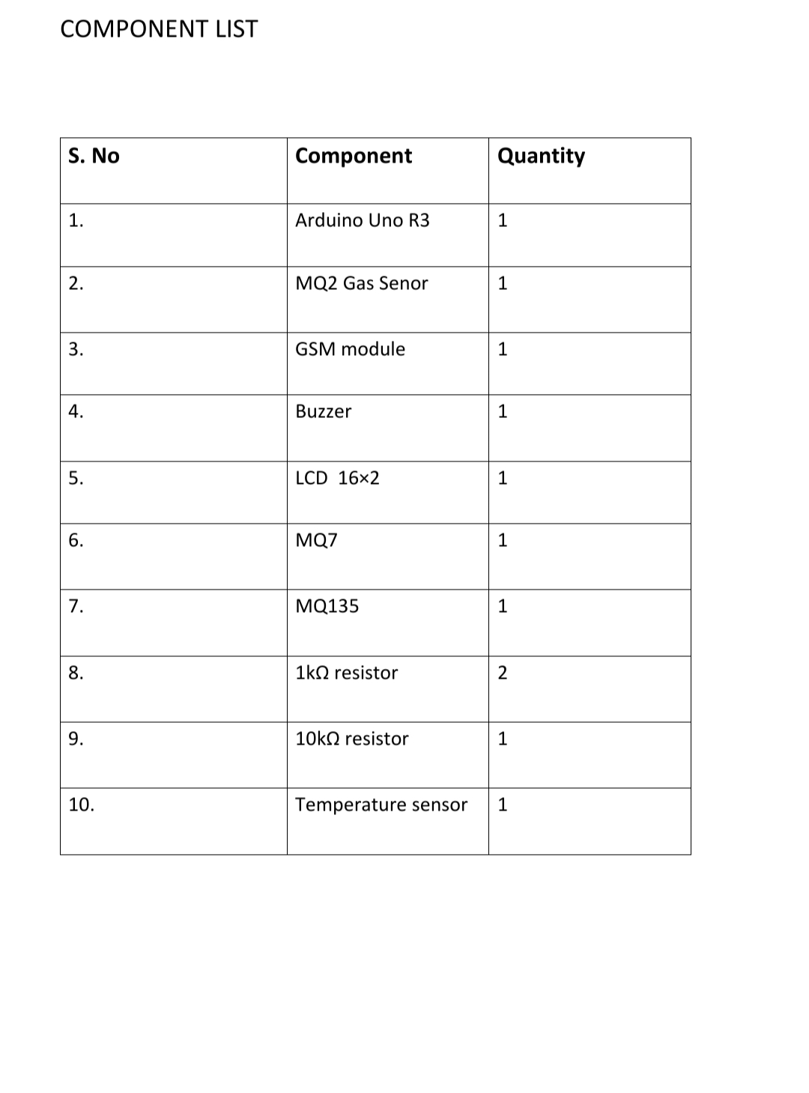

# Circuit Diagram:-

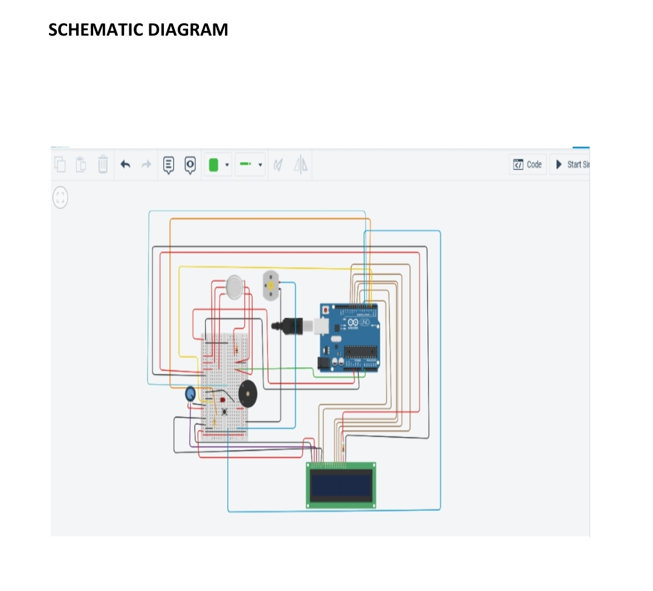

# Solution Statement :-

The system can be taken as a small attempt in connecting the existing primary gas detection methods to a mobile platform integrated with IoT platforms. The gases are sensed in an area of 1m radius of the rover and the sensor output datas are continuously transferred to the local server. The accuracy of sensors are not upto the mark thus stray gases are also detected which creates an amount of error in the outputs of the sensors, especially in case of methane. Further the availability and storage of toxic gases like hydrogen sulphide also creates problems for testing the assembled hardware. As the system operates outside the pipeline, the complication of system maintenance and material selection of the system in case of corrosive gases is reduced. Thus the system at this stage can only be used as a primary indicator of leakage inside a plant. Conclusion :-

After this project performance, can conclude that detection of the LPG gas leakage is incredible in the project system. Applicable usefully in the industrial and domestic purpose. In danger situations we are able to save the life by using this system. An alert is indicated by the GSM module. A sensor node senses gas like CO2, oxygen, propane. The estimated range of transmission and consumption of power is obtained. The simple procedures and Arduino UNO Micro controller area used to build the sensor.